### 

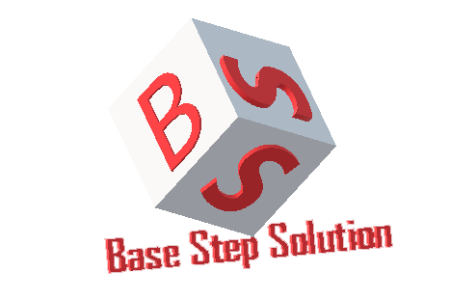

Risk Management Plan

Văn Lang Admissions

# Revision Table

|  |  |  |  |
| --- | --- | --- | --- |
| Author | Date | Reason for changes | Version |
|  |  |  |  |
|  |  |  |  |
|  |  |  |  |
|  |  |  |  |
|  |  |  |  |

Table of Contents

Revision Table 1

1. INTRODUCTION 3

1.1. Purpose 3

1.2. Audience 3

2. Process 4

2.1. Risk Development Process 4

2.2. Implement and Monitor Process 5

2.2.1. Review and Update Process 5

2.2.2. Prevent and Reduce Risk Process 6

2.3. Legends 6

2.4. Activities 7

3. Quantification 8

3.1. Risk Status 8

3.2. Risk Probability 8

3.3. Risk Severity 8

3.4. Risk Level 9

3.5. Risk Level Calculation 9

4. Roles and Responsibilities 10

5. Risk List 10

6. Risk Metrics 11

6.1. Goal-Question-Metric 11

6.2. Metric Definition 11

# INTRODUCTION

## Purpose

## Audience

# Process

## Risk Development Process

## Implement and Monitor Process

### Review and Update Process

### Prevent and Reduce Risk Process

## Legends

## Activities

|  |  |  |  |  |
| --- | --- | --- | --- | --- |
| Action | Description | Input | Output | Role |
|  |  |  |  |  |
|  |  |  |  |  |
|  |  |  |  |  |
|  |  |  |  |  |
|  |  |  |  |  |
|  |  |  |  |  |

# Quantification

## Risk Status

|  |  |
| --- | --- |
| Status of Risk | Description |
|  |  |
|  |  |
|  |  |
|  |  |
|  |  |

## Risk Probability

|  |  |
| --- | --- |
| Ranking | Probability |
|  |  |
|  |  |
|  |  |
|  |  |
|  |  |

## Risk Severity

|  |  |
| --- | --- |
| Ranking | Impact |
|  |  |
|  |  |
|  |  |
|  |  |
|  |  |

## Risk Level

|  |  |  |
| --- | --- | --- |
| Glossary | Description | Risk score = P*S |
|  |  |  |
|  |  |  |
|  |  |  |

## Risk Level Calculation

|  |  |  |  |  |  |
| --- | --- | --- | --- | --- | --- |
|  |  | | | | |
|  |  |  |  |  |  |
|  |  |  |  |  |  |
|  |  |  |  |  |  |
|  |  |  |  |  |  |
|  |  |  |  |  |  |
|  |  |  |  |  |  |

# Roles and Responsibilities

|  |  |  |
| --- | --- | --- |
| Role | Responsibilities | Assigned to |
|  |  |  |
|  |  |  |

# Risk List

# Risk Metrics

## Goal-Question-Metric

|  |  |  |
| --- | --- | --- |
| **Goal** | **Question** | **Metric** |
|  |  |  |
|  |  |  |
|  |  |  |

## Metric Definition

|  |  |  |  |  |  |  |
| --- | --- | --- | --- | --- | --- | --- |
| **ID** | **Name of metric** | **Formula** | **Goals** | **Collect procedure** | **Analyze procedure** | **Frequency** |
|  |  |  |  |  |  |  |
|  |  |  |  |  |  |  |
|  |  |  |  |  |  |  |